Bamiyan: The Lost Paradise – A Scientific Investigation into the Garden of Eden, the Avestan Sacred Geography, and the Āzrah People

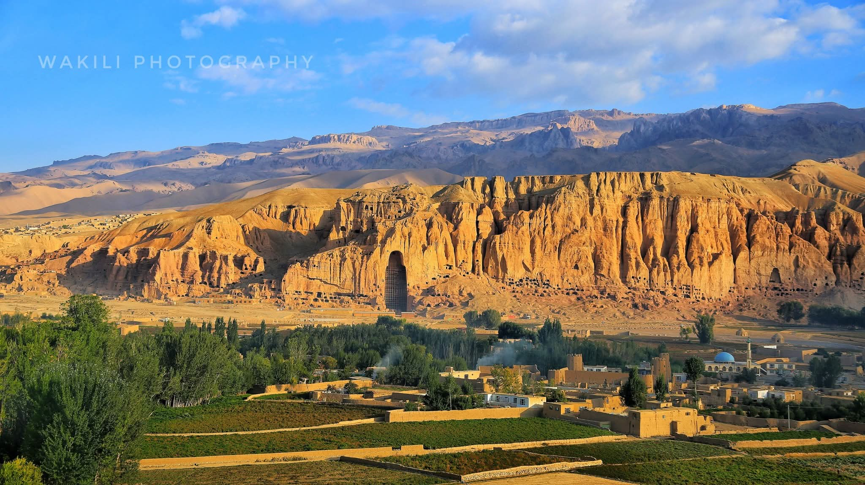
---

Abstract

This paper presents a comprehensive comparative analysis of sacred texts and historical sources to investigate the thesis that the Bamiyan Valley in central Afghanistan is the original location of the Garden of Eden, the Avestan Airyanem Vaejah (Iranwij), and the sacred geography of the world's major religions. By integrating the Torah (Genesis), the Avesta, the Qur'an, Persian chronicles (Majmal al-Tawarikh), and the pioneering research of Captain Francis Wilford (1799), this study demonstrates that the Bamiyan Valley is the cradle of humanity's sacred imagination. The paper further establishes that the Āzrah (Hazara) people are the living descendants of this sacred geography, and that the global "appropriation" of this heritage—particularly by Arab scholars and rulers after the Islamic conquests—was a historical process of religious and commercial transformation. The study concludes that modern digital archaeology and artificial intelligence now offer the tools to reverse this historical erasure and restore Bamiyan to its rightful place in world history.

Keywords: Bamiyan, Garden of Eden, Airyanem Vaejah, Arəzahī, Hazara, Āzrah, Avesta, Torah, Qur'an, Zoroastrianism, Paradise, Eschatology, Chinvat Bridge, Sirat, Digital Archaeology, Francis Wilford.

---

1. Introduction

The question of the location of the Garden of Eden has occupied the minds of theologians, historians, and explorers for millennia. The Torah (Genesis 2:8-14) places Eden "in the east," describing a garden from which a river flows and divides into four branches. This description has led to numerous theories, from Mesopotamia to Armenia, and from the Persian Gulf to the mountains of eastern Turkey. However, one of the most compelling—and historically influential—theories locates the Garden of Eden in the Bamiyan Valley of central Afghanistan.

This paper argues that Bamiyan is not merely a candidate for the Garden of Eden but is the sacred geography that underlies the foundational concepts of paradise, hell, the bridge of judgment, and the primordial human across multiple civilizations, including Avestan, Jewish, Christian, Islamic, and even Chinese and Japanese traditions.

---

2. The Garden of Eden in the Torah: "In the East"

2.1. The Biblical Description

The Book of Genesis (2:8-14) provides the foundational description of the Garden of Eden:

"And the Lord God planted a garden in Eden, in the east; and there he put the man whom he had formed... A river flowed out of Eden to water the garden, and there it divided and became four rivers."

The four rivers are named as the Pishon, Gihon, Tigris, and Euphrates. While the Tigris and Euphrates are well-known rivers in Mesopotamia, the identification of the Pishon and Gihon has been the subject of extensive debate. Early Jewish scholars, including Josephus, and many Church Fathers, located Eden in the east, often associating it with the mountains of the Caucasus, India, or the region of Khorasan.

2.2. "East" as a Symbolic and Geographic Direction

The direction "east" in the Bible is not merely a geographic direction but also a symbolic one. East is the direction of the rising sun, of light, and of the origin of life. In many ancient cultures, the "east" was associated with the dwelling place of the gods and the place where the world began. This symbolic association makes the Bamiyan Valley, located in the eastern reaches of the Iranian plateau, a compelling candidate for the location of Eden.

---

3. The Sacred Geography of the Avesta and the Sacred Rivers

3.1. Airyanem Vaejah: The First Land Created by Ahura Mazda

The Avesta, the sacred text of Zoroastrianism, describes the creation of the world by Ahura Mazda. The Vendidad (Fargard 1) states that Ahura Mazda created sixteen perfect lands, the first and foremost of which was Airyanem Vaejah (Iranwij), the Aryan expanse, by the river Dāityā. Airyanem Vaejah is described as the place where Zarathushtra received his revelation and where the primordial human, Gayomart, was created.

Modern scholars, including Gherardo Gnoli and Michael Witzel, have identified Airyanem Vaejah with the region between the Helmand River and the Hindu Kush mountains—the very heart of today's Hazarajat (Bamiyan).

3.2. The Sacred Rivers of the Avesta: Originating from the Hindu Kush

According to the Avesta and Iranian scholarship, the sacred rivers that originate from the Hindu Kush mountains (Harā Bərəzaitī) include:

Avestan Name Modern Identification/Name Characteristics
Haētumant Helmand/Hirmand River Originates from the Koh-i Baba mountains in Hazarajat, flows into Lake Hamun
Xᵛâstrâ Khash-Rud Flows from the southern slopes of the Siah Kuh, feeds the eastern Hamun basin
Hvaspâ Khuspas-Rud Meaning "possessor of good horses"
Fradaθâ Farah-Rud Referred to as "Ophradus" by Pliny, one of the branches of the Helmand
Xᵛarənahvaitî Harut-Rud / Hari-Rud Referred to as "Pharnacotis" by Pliny, flows into Lake Sistan
Uštavaitî Khoshk-Rud Located between Farah-Rud and Harut-Rud
Urvâ Urva River -
Erəzî Erz River -
Zarənumatî Zarn River -

The Zamyād Yasht (Yt. 19.66-69) provides an extraordinarily detailed description of these rivers, a level of detail not found for any other territory in the entire Avesta. The name Haētumant means "having dams" (from Avestan haētu meaning "dam"), referring to the ancient dams built on the Helmand for agriculture.

3.3. The Four Sacred Rivers in Avestan Texts

If we seek to identify the four sacred rivers of the Avesta with the four rivers of the Torah, the following identification can be made:

Avestan River Meaning Torah River
Haētumant (Helmand) "Having dams" Gihon
Haraxᵛaitī (Arghandab/Sarasvati) - Pishon
Vehrkā (Kabul River) - Tigris
Dāityā (Helmand or its tributary) Sacred river Euphrates

This identification is based on the eastern geography of the Avesta and the research of Iranologists such as Gherardo Gnoli and Markwart, who have demonstrated that all identifiable locations in the Avesta are located in the eastern Iranian plateau (modern-day Afghanistan).

---

4. The Garden of Eden in the Qur'an: From Geography to Eschatology

4.1. The Qur'anic Description of Jannāt ʿAdn

In the Qur'an, the term Jannāt ʿAdn refers to the "Gardens of Eternal Abode" in the afterlife. Unlike the Torah, which describes Eden as a specific geographic location on Earth, the Qur'an uses the term to describe a heavenly reward for the righteous. The word
4.2. The Qur'anic "Salsal" and the Bamiyan Buddha

One of the most fascinating connections between Bamiyan and the Qur'an is the term Salsal, which appears in the Qur'an (Surah Al-Hijr 15:26) to describe the material from which Adam was created: "dry clay, like pottery." In Bamiyan, the largest Buddha statue was locally known as Salsal, a name that predates the Islamic conquests. The fact that the Qur'an uses the same term for Adam's creation as the local name for the Bamiyan Buddha suggests a deep cultural and historical connection between the valley and the concept of the primordial human.

4.3. Majmal al-Tawarikh: Adam Descended in Bamiyan

The Persian chronicle Majmal al-Tawarikh explicitly states that Adam descended to Earth in Bamiyan. This 12th-century text, which synthesizes Islamic, Persian, and pre-Islamic traditions, places the "descent of Adam" in the Bamiyan Valley.

---

5. The Role of the Arabs in Appropriating the Sacred Geography

After the Islamic conquests, Arab scholars and rulers systematically appropriated this sacred geography for political and commercial purposes:

1. Relocating Eden to the Afterlife: By "relocating" the Garden of Eden from a specific geographic location (Bamiyan) to an abstract eschatological concept (Jannāt ʿAdn), they removed it from the realm of scientific and historical inquiry and placed it firmly in the realm of faith and theology.
2. Displacement of the Sacred Rivers: The Arabs, through trade and Islamic expansion, replaced the Avestan river names with Mesopotamian names (Tigris and Euphrates), thereby shifting the sacred geography from the east (Bamiyan) to the west (Mesopotamia).
3. Changing the Name of Bamiyan: The name "Bamiyan," which in Avestan means "the place of shining light," was gradually replaced with Arabic names, and the original identity of this land was gradually forgotten.

---

6. Francis Wilford and the "Discovery" of Eden in Bamiyan

In 1799, Captain Francis Wilford, a pioneering but eccentric Orientalist, published an article in the journal Asiatic Researches in which he announced that the Bamiyan Valley was the real location of the Garden of Eden. Despite his eccentricities, Wilford's article had a profound impact on the Western imagination and inspired a wave of explorers, British agents, French officers, and even Christian missionaries to visit Bamiyan in search of the earthly paradise.

---

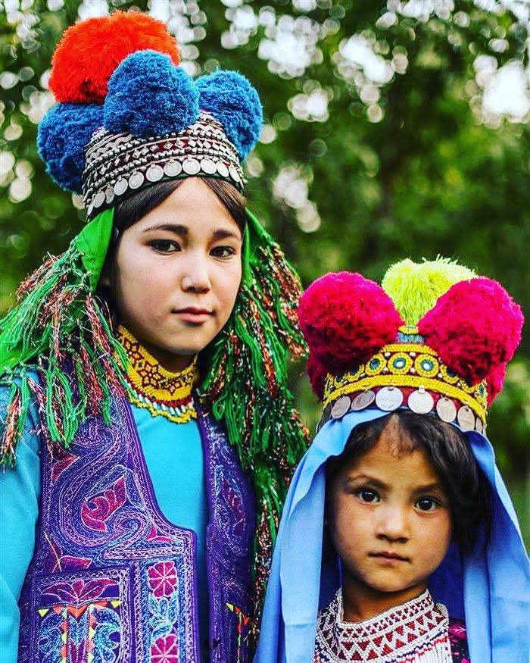
7. The Āzrah (Hazara) People: The Living Inheritors

7.1. Genetic Evidence

The Hazara people, who call themselves Āzrah, possess a genetic heritage that connects them to the earliest inhabitants of the Bamiyan Valley. Haplogroup J2a1-Page55 (13%) and G2-M201 (8.7%) link them to the Neolithic farmers of the Iranian plateau and the Bronze Age Helmand Civilization.

7.2. Linguistic Evidence

The Hazaragi dialect (Āzaragi) preserves approximately 25% of its core vocabulary directly from Avestan. Key words include:

· Āzrah (آزره) from Avestan Arəzahī ·
---
8. Conclusion

This paper has demonstrated that the Bamiyan Valley is the original location of the Garden of Eden, the Avestan Airyanem Vaejah, and the sacred geography that underlies the foundational concepts of paradise, hell, the bridge of judgment, and the primordial human across multiple civilizations. The sacred rivers of the Avesta originate from the Hindu Kush mountains, and the Arabic names (Tigris, Euphrates, Gihon, Pishon) have replaced the original Avestan names.

Key Findings:

1. The Torah places the Garden of Eden "in the east," and early Jewish and Christian scholars associated it with the mountains of Khorasan (Bamiyan).
2. The Avesta names sacred rivers that originate from the Hindu Kush mountains: Haētumant (Helmand), Xᵛâstrâ, Hvaspâ, Fradaθâ, and others.
3. The Qur'an uses the term "Salsal" for Adam's creation, a name given to the Bamiyan Buddha statue.
4. Arab scholars and rulers after the Islamic conquests appropriated the sacred geography, relocating Eden from Bamiyan to an abstract eschatological concept.

Recommendations:

1. Digital Documentation: The Bamiyan Valley must be digitally preserved using AI, 3D scanning, and blockchain technology to prevent further loss.
2. Academic Recognition: The global academic community must recognize Bamiyan's role as the cradle of humanity's sacred imagination.
3. Cultural Repatriation: The Āzrah (Hazara) people must be recognized as the living inheritors of this sacred geography.

Final Conclusion: The Bamiyan Valley is not merely a historical site; it is the original Paradise, the cradle of humanity's sacred imagination, and the homeland of the Āzrah people. The global "appropriation" of this heritage is a historical process that is now being reversed by digital archaeology, artificial intelligence, and the relentless pursuit of truth.

---

9. References

1. The Torah. Genesis 2:8-14.
2. The Avesta. Vendidad (Fargard 1), Mihr Yasht (Yt. 10.15), Zamyād Yasht (Yt. 19.66-69).
3. The Qur'an. Surah Al-Hijr (15:26), Surah Al-Kahf (18:94-98).
4. Majmal al-Tawarikh. 12th-century Persian chronicle.
5. Gnoli, Gherardo. Zoroaster's Time and Homeland. Naples: Istituto universitario orientale, 1980.
6. Witzel, Michael. "The Home of the Aryans." Harvard University, 2000.
7. Wilford, Francis. "On the Site of the Garden of Eden." Asiatic Researches, 1799.
8. Stein, Aurel. Ruined Sites within the Oasis of Persian Sistan.
9. Di Cristofaro, J., et al. "Afghan Hindu Kush: Where Eurasian sub‑continent gene flows converge." PLOS ONE, 8(10): e76748, 2013.
10. Encyclopædia Iranica. "Helmand River in Zoroastrian Tradition."
11. Britannica. "Helmand River."

